|  |  |
| --- | --- |
| **Assignment Case** |  |
| COMP6153  Operating System |
| **Computer Science** | **O213-COMP6153-DX02-01** |
| ***Valid on*** *Odd Semester Year 2020/2021* | **Revision 00** |

1. Seluruh mahasiswa tidak diperkenankan untuk:

*All students are not allowed to:*

* + 1. Melihat sebagian atau seluruh jawaban mahasiswa lain,

*Seeing a part or the whole answer from other student*

* + 1. Menyadur sebagian maupun seluruh jawaban dari buku,

*Adapted a part or the whole answer from the book*

* + 1. Mendownload sebagian maupun seluruh jawaban dari internet,

*Downloading a part or the whole answer from the internet,*

* + 1. Mengerjakan soal yang tidak sesuai dengan tema yang ada di soal,

*Working with another theme which is not in accordance with the existing theme in the matter of the case,*

* + 1. Melakukan tindakan kecurangan lainnya,

*Committing other dishonest actions,*

* + 1. Secara sengaja maupun tidak sengaja melakukan segala tindakan kelalaian yang menyebabkan hasil karyanya berhasil dicontek oleh orang lain / kelompok lain.

*Accidentally or intentionally conduct any failure action that cause the results of the project was copied by someone else / other groups.*

1. Jika mahasiswa terbukti melakukan tindakan seperti yang dijelaskan butir 1 di atas, maka **nilai mahasiswa** yang melakukan kecurangan (menyontek maupun dicontek) akan di – **NOL** – kan.

*If the student is proved to the actions described in point 1 above, the score of the student which committed dishonest acts (cheating or being cheated) will be “Zero”*

1. Perhatikan jadwal pengumpulan jawaban, segala jenis pengumpulan jawaban di luar jadwal tidak dilayani.

*Pay attention to the submission schedule, all kinds of submission outside the schedule will not be accepted*

1. Persentase penilaiaan untuk matakuliah ini adalah sebagai berikut:

*Marking percentage for this subject is described as follows:*

|  |  |  |
| --- | --- | --- |
| **Tugas Mandiri**  *Assignment* | **Proyek**  *Project* | **UAP**  *Final Exam* |
| 40% | - | 60% |

1. Software yang digunakan pada matakuliah ini adalah sebagai berikut:

*Software will be used in this subject are described as follows:*

|  |
| --- |
| **Software**  *Software* |
| VM Ubuntu Client 20.04  Java 8  Eclipse 2020.6  NachOS 5.0j |

## Ekstensi file yang harus disertakan dalam pengumpulan tugas mandiri dan uap untuk matakuliah ini adalah sebagai berikut:

*File extensions should be included in assignment and project collection for this subject are described as follows:*

|  |  |  |
| --- | --- | --- |
| **Tugas Mandiri**  *Assignment* | **Proyek**  *Project* | **UAP**  *Final Exam* |
| DOCX, JAVA, CLASS | - | JAVA, CLASS |

## Soal

*Case*

1. From the **home directory**, write a **command line** to create a directory based on the hierarchy below in a single execution!

<Home directory>

`-- BookStore

|-- Products

| |-- RegularBook

| |-- PremiumBook

|-- Categories

| |-- Comedy

| |-- Romance

| |-- Fiction

1. Write a command line to create a new file named **Category.txt** inside the **Categories** folder, then **set permission** so the **owner** able to **read**, **write,** and **execute** the **file**. **Groups will be able** to **read and write**, while **others are** only able to **execute** the file.
2. From **BookStore folder,** write a command line to **search files** with the following criteria:

* **Inside BookStore folder**
* **Size below 500 KB**
* **The types are .txt**

1. Write a command line to display **all processes for users** in the system, **filtered** bythe username that must be **root**.

**Java Programming**

**DeluXe Book Store**

**DeluXe Book Store** is the biggest bookstore located in Jakarta. As a programmer, you are asked to create a program to handle customer orders.

Here are the detail requirements of the application:

* The application use **Object Oriented Programming** concept and **Inheritance**
* Create methods to calculate the **Base Price**, **Size** **Price,** and **Total Price**
* When the **program starts**, ask the user to **input the menu** **they want to** **order**. **The program consists of 2 menus:**

1. **Regular Book**
2. **Premium Book**



**Figure 1. Screenshot of Menu**

* If the user chooses **menu 1**(“**Regular Book**”), then:
* Ask the user to input the **book’s category**. Validate the inputted **category** must be among these 3 choices which are “**Comedy**”, “**Romance**”, or “**Fiction**”. (**case sensitive)**
* Ask the user to input **Name**. Validate the **Name** must be between **5 and 15 characters.**
* Ask the user to input **Total Pages of the Book**. Validate the **Total Pages** must be **equals or more than 50 pages.**

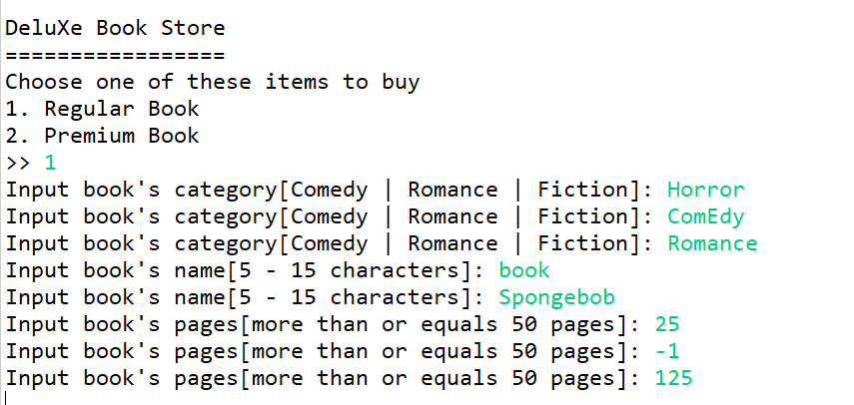

**Figure 2. Screenshot of input Regular Book order**

* Determine the **Base** **Price** based on the following rules:

|  |  |
| --- | --- |
| **Category** | **Base Price** |
| Comedy | 55000 |
| Romance | 58000 |
| Fiction | 60000 |

* Determine the **Additional Price** with the following formula:

|  |  |
| --- | --- |
| **Total Pages** | **Additional Price** |
| More than or equals 50 pages | 10% of Base Price |
| More than or equals 100 pages | 20% of Base Price |
| More than or equals 150 pages | 30% of Base Price |

* Calculate the **Total Price** with the following formula:

**Total Price = Base Price + Additional Price**

* Display **Name**, **Category**, **Total Pages**, **Total Price** of the inputted order

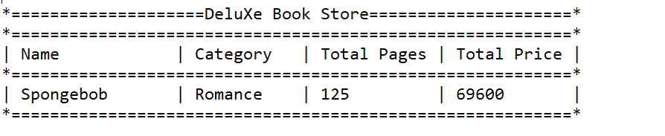

**Figure 3. Screenshot of View Regular Book Order**

* If the user chooses menu 2(“**Premium Book**”), then:
* Ask the user to input the **book’s category**. Validate the inputted **category** must be among these 3 choices which are “**Comedy**”, “**Romance**”, or “**Fiction**”. (**case sensitive)**
* Ask the user to input **Name**. Validate the **Name** must be between **5 and 15 characters.**
* Ask the user to input **Total Pages of the Book**. Validate the **Total Pages** must be **equals or more than 50 pages.**
* Ask the user to input the **book’s cover.** Validate the inputted **cover** must be between “**Soft**” and “**Hard**”. (**case sensitive**)

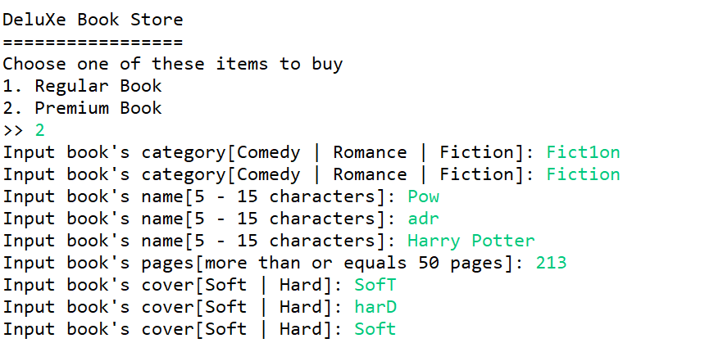

**Figure 4. Screenshot of Add Order**

|  |  |
| --- | --- |
| **Cover** | **Variation Price** |
| Soft | 15000 |
| Hard | 10000 |

* Then, calculate the **Total Price** with the following formula:

**Total Price = Base Price + Additional Price + Variation Price**

* Display **Name**, **Category**, **Total Pages, Cover** and **Total** **Price** of the inputted order

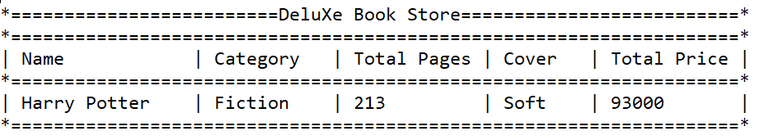

**Figure 5. Screenshot of View Premium Book Order**